# Predicting bacterial growth conditions from mRNA and protein abundances

**Supplementary file**

Mehmet U. Caglar1, Adam J. Hockenberry1, Claus O. Wilke1*

1Department of Integrative Biology, The University of Texas at Austin, Austin, Texas, USA

*Corresponding author: [wilke@austin.utexas.edu](mailto:wilke@austin.utexas.edu)

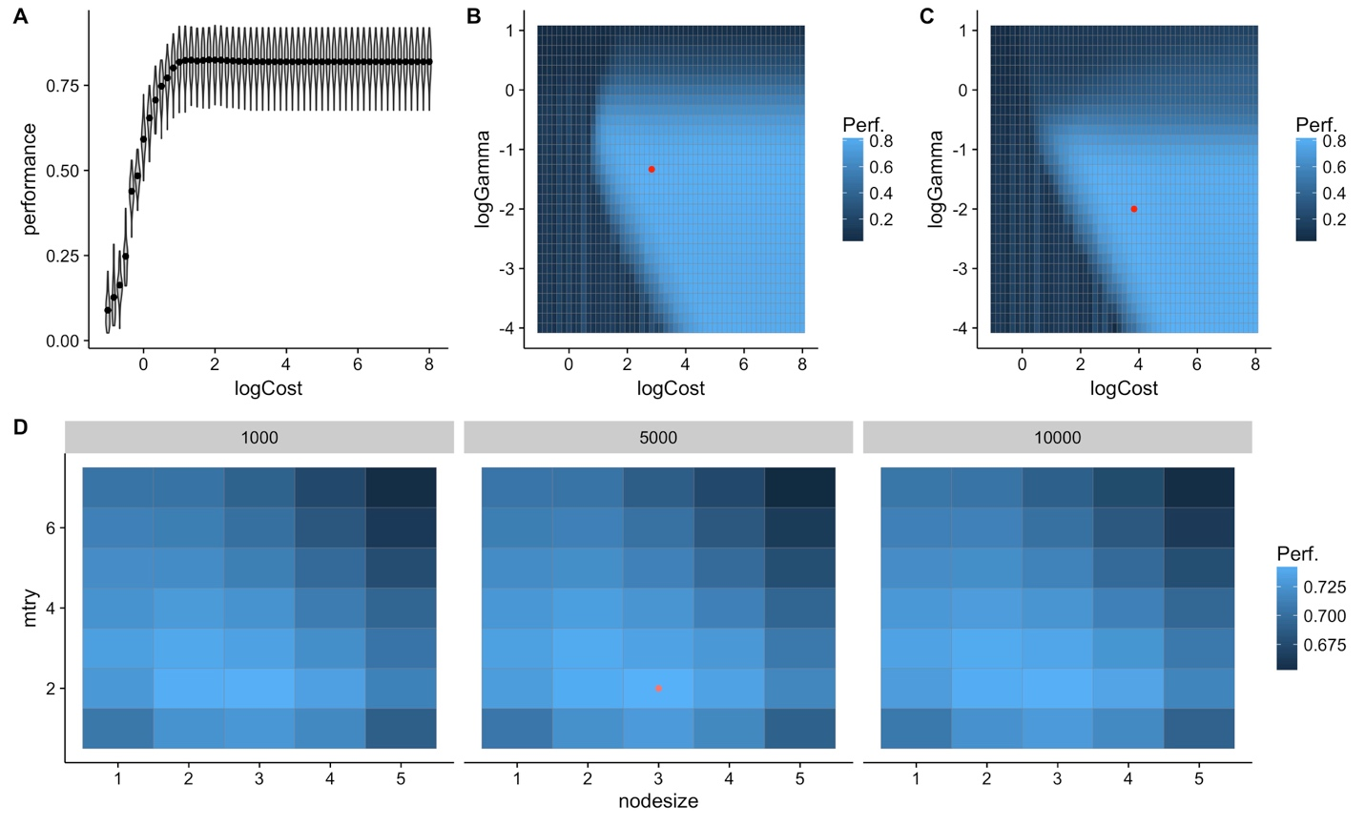

**Supplementary figure 1.** The model parameter and error distribution for mRNA data. A. parameter and error distribution with SVM using linear kernel, B. parameter and error distribution with SVM using radial kernel, C. parameter and error distribution with SVM using sigmoidal kernel, D. parameter and error distribution with SVM using random forest. SVM with radial kernel gives the best results xx/60 of the independent training&tuning runs.

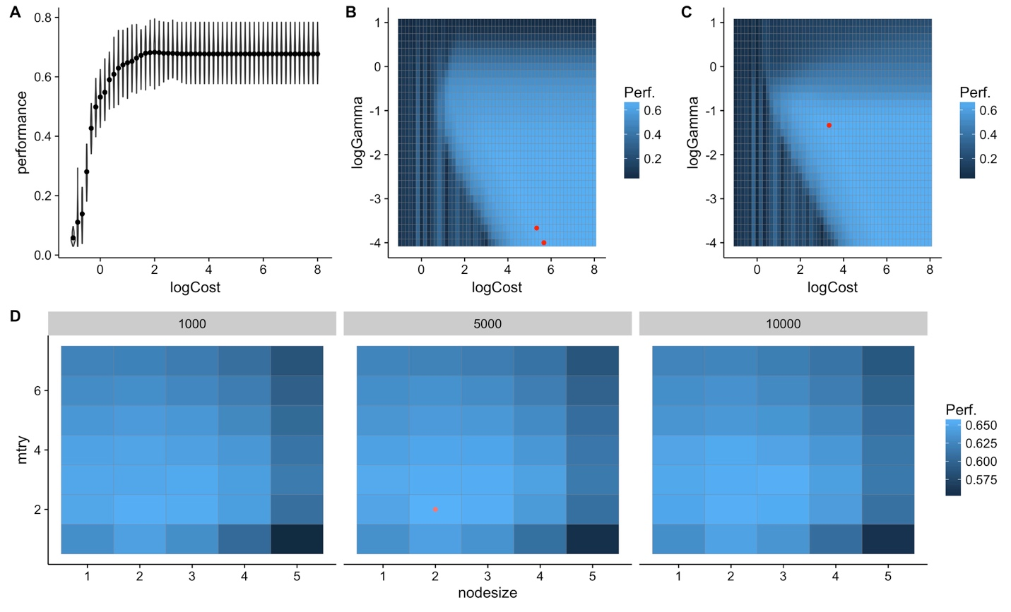

**Supplementary figure 2.** The model parameter and error distribution for protein data. A. parameter and error distribution with SVM using linear kernel, B. parameter and error distribution with SVM using radial kernel, C. parameter and error distribution with SVM using sigmoidal kernel, D. parameter and error distribution with SVM using random forest. SVM with sigmoidal kernel gives the best results xx/60 of the independent training&tuning runs.

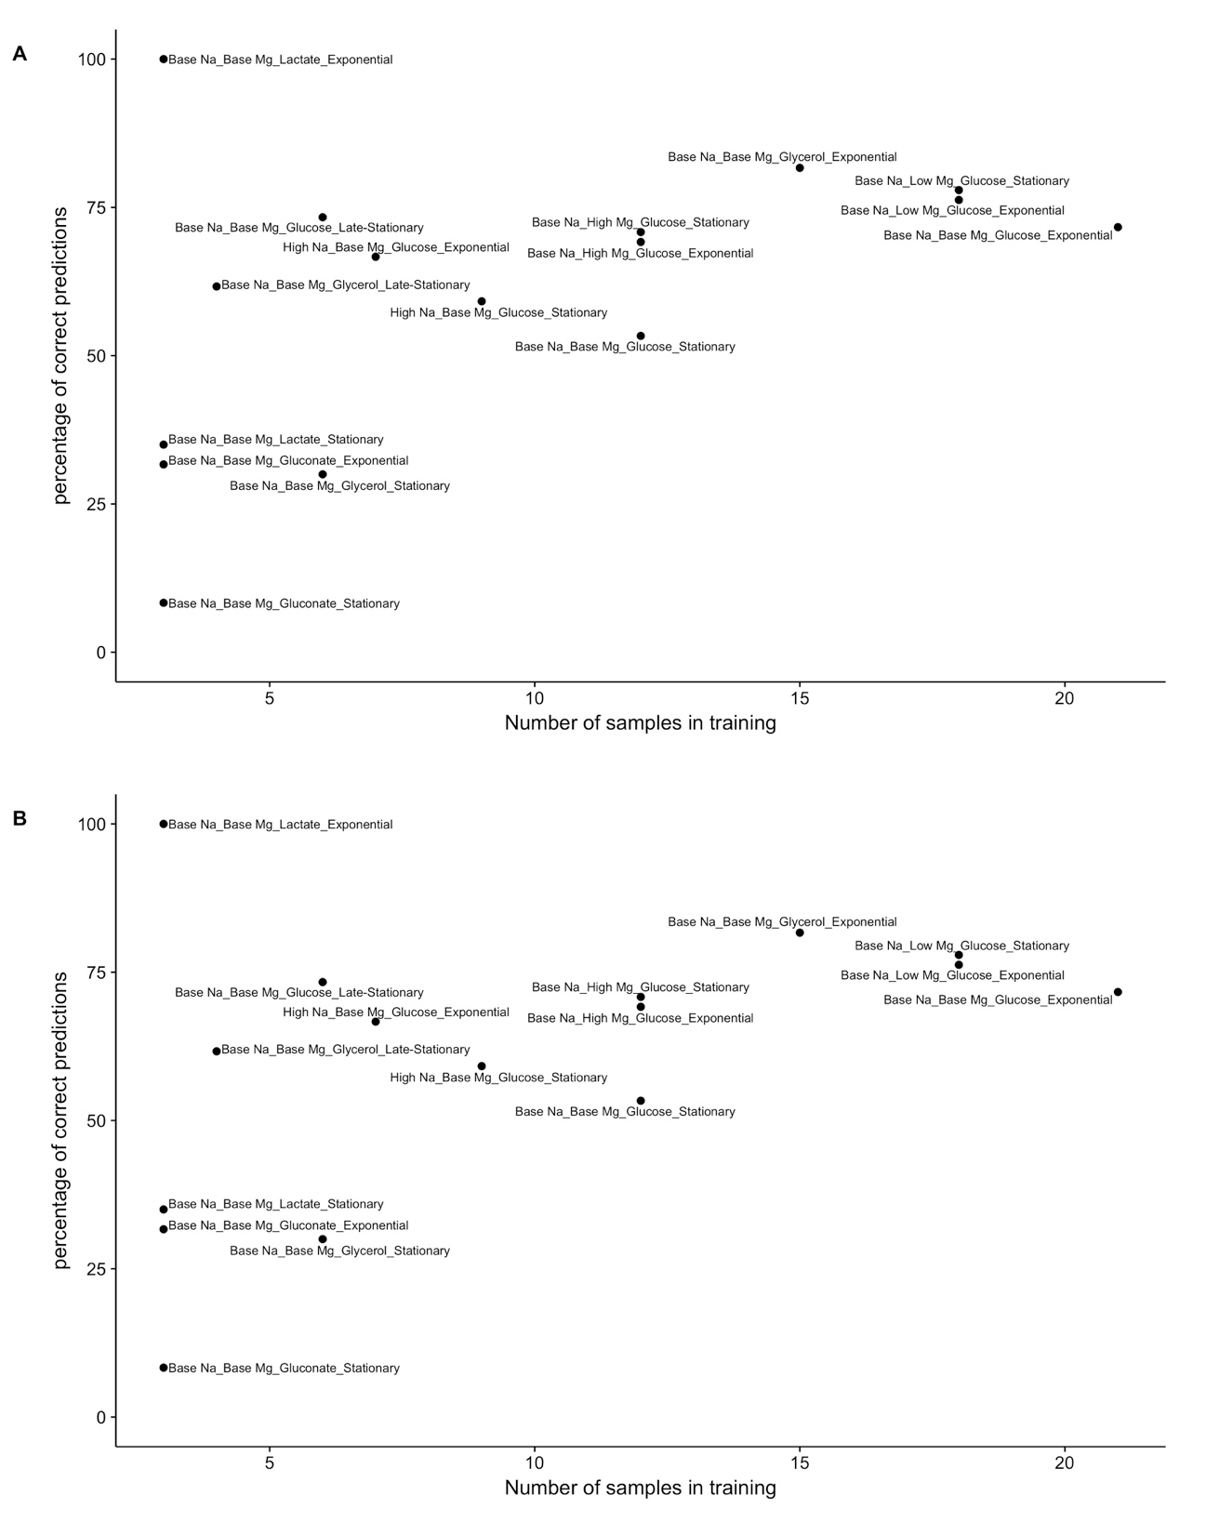**Supplementary figure 3**. The precision of individual conditions in tests for mRNA (A) and protein (B) datasets with respect to number of samples in training data.



**Supplementary figure 4.** The error count distribution for mRNA (A) and protein (B) confusion matrixes.



**Supplementary figure 5.** Complex predictions with intersection mRNA data. Corresponding multivariate F1 score is xx



**Supplementary figure 6.** Complex predictions with intersection protein data. Corresponding multivariate F1 score is xx



**Supplementary figure 7.** Complex predictions with intersection combined mRNA and protein data. Corresponding multivariate F1 score is xx

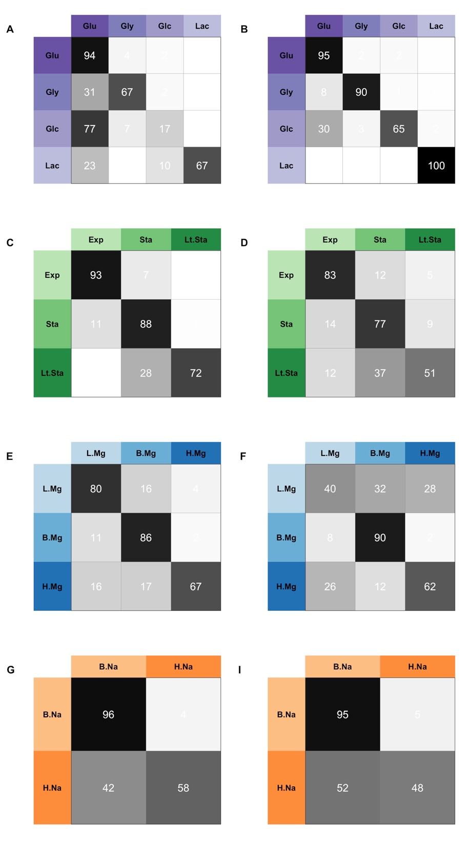

**Supplementary figure 8.** Four distinctIndividual tests for mRNA and protein data. A. Carbon source for mRNA, B. carbon source for protein, C. growth phase for mRNA, D. growth phase for protein, E. Mg+2 levels for mRNA, F. Mg+2 levels for proteins, G. Na+1 levels for mRNA, H. Na+1 levels for proteins.

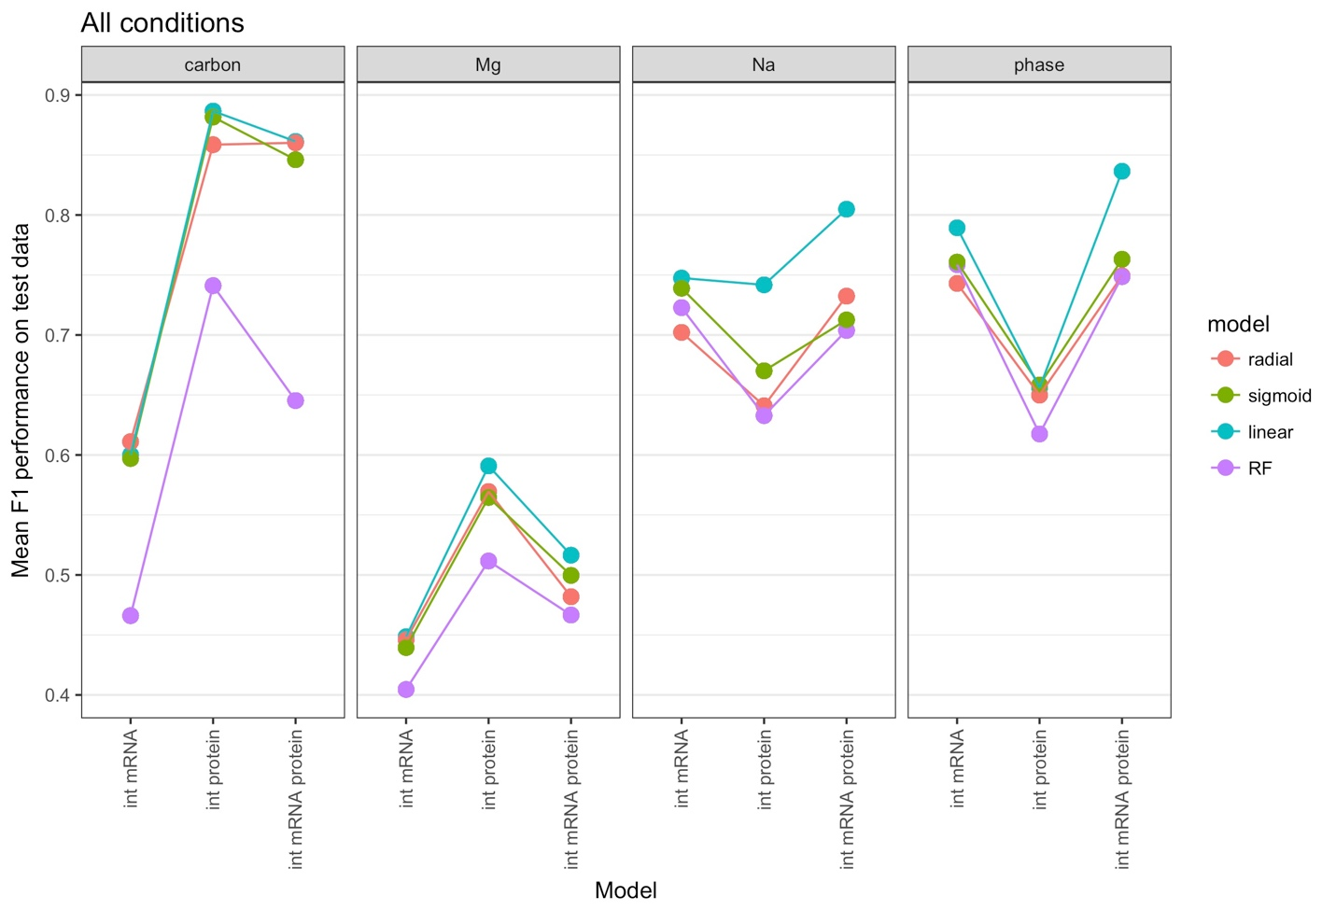

**Supplementary figure 9.** The performance change between intersection mRNA, intersection protein and combined datasets for individual tests.

**Supplementary Table 1:** Number of distinct values each parameter takes during tuning process for each model. Each model with each parameter combination is trained with 10 distinct train-tune divisions of train&tune subset. To find the best model mean score of those 10 independent runs are averaged.

A

|  |  |  |
| --- | --- | --- |
|  | cost | gamma |
| SVM, linear kernel | 55 | NA |
| SVM, radial kernel | 55 | 31 |
| SVM, sigmoidal kernel | 55 | 31 |

B

|  |  |  |  |
| --- | --- | --- | --- |
|  | mtry | ntree | nodesize |
| Random Forest | 7 | 3 | 5 |